2018
Diverse City and
Ramps on the Moon
Youth Theatre Training

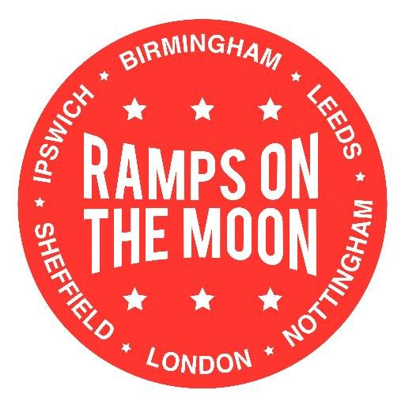

“It's a great introduction to thinking about accessibility requirements in the theatre and it gives you more confidence in delivering accessible sessions and holding conversations with management.”
Participant, Birmingham Rep

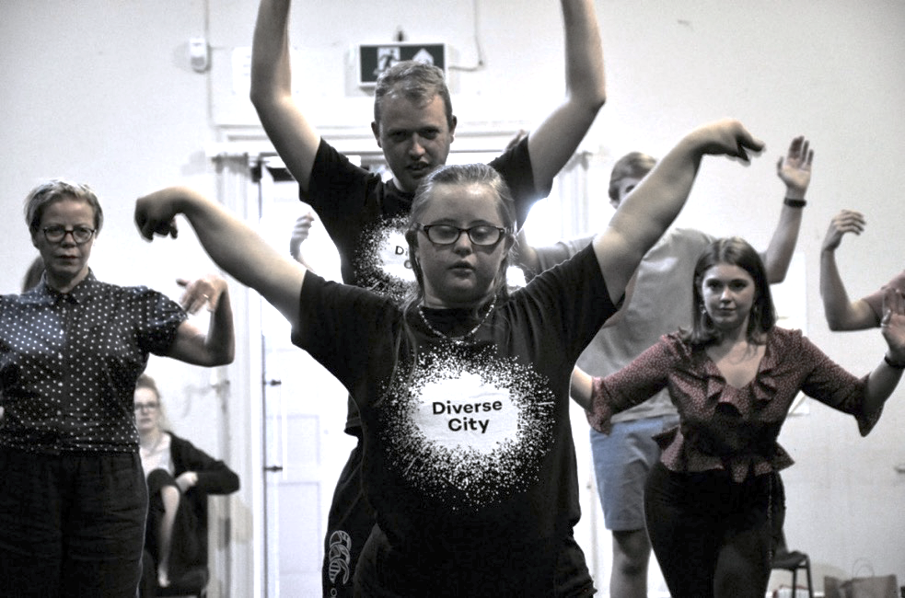

Photo credit: ©Dave Brookes New Wolsey Theatre in partnership with Theatre Royal Stratford East.
Image description: Dancers stand in the space with their arms in the air, rehearsing a routine.

Contents

1. The Partners 4
2. Aims & Objectives of the partnership 5
What we aimed to do 5
How we did it 6
3. Share best practice of working inclusively 7
The starting point 7
Impact 8
Next Steps 9
4. How integrated arts participation and training can increase inclusion 10
The starting point 10
Impact 10
Next Steps 12
Appendix 1 13
Where and When we did it 13
Appendix 2 13
Who attended 13

The Partners

Ramps on the Moon (ROTM)
Ramps on the Moon is a critical movement in the UK theatre sector, striving for a step change in the inclusion and integration of D/deaf and disabled individuals. Led by New Wolsey Theatre, Ipswich, Ramps on the Moon brings together a collaborative network of six National Portfolio Organisation theatres including New Wolsey Theatre, Ipswich, Birmingham Repertory Theatre, Theatre Royal Stratford East, Nottingham Playhouse, Leeds Playhouse, Sheffield Theatres and strategic partner Graeae Theatre.
ROTM sees Youth Theatre as an important part of the theatre landscape. It is the place where young D/deaf and disabled people can find out what the theatre has to offer them - as a hobby or a future career. With investment, accessible and integrated opportunities in youth theatre can become more widely available across ROTM consortium members.

Diverse City
Diverse City is a wide family of artists and activists who are experts in diversity, access and integration. Jamie Beddard is joint Artistic Director with Claire Hodgson and together they lead ground breaking performance that smashes assumptions and stretches possibilities. Diverse City makes extraordinary shows for, with and by people facing barriers to access: shows that reflect the world as it actually is. We make unlikely alliances that increase representation in the arts on and off stage and in the audience and widen pathways into the performing arts through consultancy and training.

Aims and Objectives of the Partnership

This partnership aimed to support the normalisation of disabled people in the theatre industry as participants, performers and audience members in two ways:

- By focusing on the best practice of working inclusively with D/deaf, disabled and non-disabled young people

- By suggesting ways that integrated arts participation and training can increase inclusion of D/deaf and disabled individuals.

What We Aimed To Do

- To share best practice of working inclusively

  - By exploring how aesthetics of inclusion stretch the range of our rehearsal room exercises and approach

  - By discovering how experiments in integrated creative access can enhance our own creative thinking and theatre practice more widely

- To suggest how integrated arts participation and training can increase inclusion

  - By agreeing practical steps to take now within our arts practice and training to increase inclusion

How We Did It

Ramps on the Moon commissioned Diverse City to share the inclusive, creative practice developed with its Youth Company, Extraordinary Bodies Young Artists. The sessions were a mix of practical exercises, discussion and brainstorming. The activity supported conversations between youth theatre directors and facilitators about making their programmes, projects and sessions more inclusive.

Diverse City proposed three, day long practical workshops - ‘The Inclusive Rehearsal Room’ - for participants from all 6 consortium members, held in 3 venues. Each session aimed to increase the confidence and shared understanding of inclusive practice amongst pairs of youth theatres across the ROTM consortium. It allowed permanent and freelance practitioners to explore fresh, practical and relevant tools and approaches.

The workshops were delivered by an integrated team of experienced and specialist practitioners who work as associate artists with Diverse City. They were joined by a select group of youth ensemble members from Extraordinary Bodies Young Artists (EBYA).

Share best practice of working inclusively

The Starting Point

The participants involved in the workshops had seen Ramps on the Moon’s work and productions and already understood what a fully inclusive production could look like, consequently the understanding of inclusivity was very good and the Diverse City artists noticed that the groups understood it in its broadest sense:
“They really took into account all barriers young people face including race, finance and disability.” Diverse City artist
The consensus to the pre-questionnaire showed that the ambition to develop integrated youth theatre provision were high: ambitions being at a 7 or 8 out of 10 (where 10 was highly ambitious).
Project Producer Louise Brown noted that the majority of the venues were very excited about the opportunity. This demonstrated that there is a desire through the venues to make a sector change in normalisation of disabled and D/deaf people in youth theatre, and that they recognised it as important in their team’s professional development:
“We are ambitious to become even more accessible and inclusive youth theatre and this opportunity offers great professional development for our staff working towards that goal” Lauren Fallon, Birmingham Rep, Learning and Participation Manager.
The consensus was that venues were already working inclusively across their youth theatres, but could benefit from further training and none regularly provided integrated practice as a CPD requirement. There was an expressed need for this kind of CPD:
“To offer as inclusive a practice and experience as possible and to challenge the ways in which we work in a positive way” Sian Thomas, New Wolsey Theatre, Creative Learning Producer.
Some venues felt that the pre-questionnaire was too limited a mechanism for delving into the specific starting points and needs of individual organisations and that for another time:
“I would ask that there be a conversation about the training expectations and needs before it took place.”
Diverse City’s capacity to speak directly to the right people about sessions and the whole project was impacted by staff changes, holidays and illness. In particular there was limited communication in engaging and investing in this project with Sheffield Theatres (due to staff changes) and Nottingham Playhouse. The actual operational set up of sessions - agreeing with the venue’s dates and locations across the 6 partners - took longer than expected and consequently the time to have in depth preparatory conversations was squeezed out.

Impact

A key feature of the Diverse City training approach is that it was delivered by specialist practitioners alongside members of our youth ensemble EBYA. Participants found this valuable and felt that of most benefit was meeting the young people from EBYA, experiencing first-hand the communication differences of a D/deaf practitioner and:
“Working with specialist practitioners to improve and advance skill set”.
The Diverse City artists felt that they had shared best practice and noted that the organisations and participants were keen and eager to learn from the approach we were presenting. David Ellington said:
“very impressive that participants were eager to listen with problem solving and they asked some good questions.”
Artists noticed that the sharing of practice around integrated creative access enhanced the playful experimentation of participants:
“The rooms were very creative and seemed to enjoy creating work with access embedded. During access using visual language and audio description, the youth directors played around, experimented and created some really interesting work.”
Artist, David Ellington, noted in particular that this work was stretching:
“they found using audio description for improvising scenes hard and challenging in the time available: as they realised it took time to do that with all the different layers to be input.”
Participants noted that their practice was being stretched:
“Discovering new and inclusive exercises and games which I can now use in my own practice and delivery”
The training served as a prompt to continue to develop and add to creative vocabulary:
“It has reminded us of the importance of being inclusive and how we will now use exercises like the ones you shared with us in our own practical work much more than before.”
There were contradictory views on the balance of theory to practice or big picture to little picture. Some people wanted:
“Some dialogue about inclusivity. What is it? Why should we do it? What might that mean for our theatres? To consider staffing, leadership roles, training.”
While others were keen to dwell on the nitty gritty for example adapting the practice of non-disabled practitioners to work physically with those who have limited mobility.
Each venue’s commitment and investment in inclusive practice varies and it was impossible for ‘The Inclusive Rehearsal Room’ to be exactly tailored to their individual needs when working in a collaborative setting.

Next Steps

Diverse City will investigate the potential for smaller, more strategic intensive working groups or residencies with youth theatre directors and producers. These would explore in more depth the ethos and practicalities of working inclusively for deeper sector change.

Diverse City will continue relationships with venues and work individually with them to offer practical, art form specific training or support in implementing the practical steps required to facilitate inclusive sessions at a senior and practitioner level based on their particular needs.

How Integrated Arts Participation and Training Can Increase Inclusion

The Starting Point

Eilis Bevan Davis, Diverse City’s Artistic Director for Extraordinary Bodies Young Artists observed that the need to increase inclusive was well understood amongst venues:
“These organisations have a good understanding of inclusion and why it’s important. All teams were productive, engaged and ready for a challenge. There are varying levels of ‘will’ amongst the team, but in each organisation we met at least a handful of people who we felt would drive the inclusion agenda.”
However, there was a lack of understanding in how working fully inclusively across all arts participation could be sustained:
“it was clear that disabled young people had been involved in particular projects but it was unclear how permanent the engagement is. Many of the youth theatre directors and leaders had experience of teaching young disabled people in outreach work but few had directed integrated shows or included young disabled people into their ongoing work.”
It was hard for Diverse City to establish where different venues were in terms of their strategic thinking. The initial set up of the workshops was challenging in relation to speaking to all six venues: youth theatre teams were often busy due to other projects and commitments and the summer wasn’t the best time for this initiative due to the many productions being delivered.

Impact

Following the training session, participants articulated clearly that there had been a change in awareness that would help them take practical steps to increase inclusion:
“It has made me much more aware of how everyone has different needs and how important it is to value these in making my sessions inclusive.”
“I’ll be even more aware of different children’s different needs/expectations and abilities.”
Participants also noted that awareness leads to constantly evaluating practice and adapting to the room by keeping inclusivity at the forefront.
The need for more proactive rather than reactive thinking to mitigate barriers to inclusion was identified:
“(I will) Consider in advance of setting up new groups how we'll manage access needs rather than having to work it out as we go along.”
“(There is a need) To be more thorough in planning sessions to include all participants at all times.”
Other practical areas for development included working with a broad range of diverse groups with D/deaf and disabled people and their access needs; using BSL more and growing understanding of BSL; using accessible language; and finding more time to explore creative access in a safe space.
One practitioner suggested the next steps for their youth provision as being:
“as an outside practitioner for the New Wolsey, what would be useful now is if all of the theatre's practitioners could come back together and discuss ways we can embed this into the work we do. Perhaps troubleshoot and discuss within the team how this can impact our day-to-day sessions working.”
Participants wanted to take practical steps around booking, paying and funding access workers, but they wanted more information. Dave Young noted that in Birmingham in particular:
“There were a lot of post it notes around access workers and money - maybe we should create a fact sheet?”
The youth theatre managers and practitioners understood that there needed to be a wider conversation to spread the impact and bring about strategic organisational change. Many were already in a change situation and could see that the work could feed into and underpin a bigger change agenda:
“It confirmed that we are inclusive in our practice, but we need as an organisation to have that conversation across all teams. It will make us have another conversation about inclusivity, in light of us in a process of re branding & re-structuring.” Youth Company Coordinator - Theatre Royal Stratford East.
“We are in a period of change…so this was well timed for discussions around youth theatre structure and new approaches to breaking down barriers…. this collective experience has brought that to the forefront of us strategically as well as on the ground for our practitioners.” Creative Learning Producer, New Wolsey Theatre.
“Hopefully it gives me lots of points to go to management with and hopefully we'll find some solutions.” Education Officer, Birmingham Rep
Because of the limited feedback to the training overall, it was unclear the degree to which participants would actively instigate new strategic practices around inclusion: 23% of participants completed feedback surveys, 90% of which were from one single session (with New Wolsey Theatre and Stratford East). It was noted by Eilis Davis (EBYA Artistic Director) that in some sessions there were many more freelancers than core staff, and this inevitably will limit access to the decision makers in management which in turn will has an impact on the potential to change policy around inclusion effectively.
However, there was an appetite to develop these strategic conversations further:
“we would like to have another session to look at strategy not just practice” New Wolsey
“I would have liked more opportunities for strategic conversations around how whole programmes can be opened up to the broadest range of participants (although I realise the w/shop was billed as being for practitioners)” New Wolsey
Diverse City’s proposition that ALL youth theatre should be inclusive (not just one-off projects or outreach programmes) was clearly provocative and Eilis noted that the session was not long enough to tackle many questions:
”related to having a separate youth theatre ‘for’ disabled people. We felt that we had to keep arguing for all the youth theatres to be inclusive.”
Eilis observed that practitioners were not entirely convinced of the benefits to their organisations and the wider sector. They continued to frame inclusive sessions as separate sessions ‘for’ disabled participants. There was a lack of understanding of
“…the need and reasoning for why ALL youth provision should be inclusive and the benefits that can bring to non-disabled young people and the benefits it can bring to their organisations.”

Next Steps

- Diverse City will offer our Practical Access workshop, with accompanying fact sheets, to those organisations and offer follow up support to the different youth theatre teams on the operational aspects of working inclusively.

- Diverse City will maintain dialogue with key youth theatre personnel and link them into our Deaf and disabled practitioner networks, training and recruitment.

- Diverse City will explore with EBYA ways to maintain links with the youth theatre provision at the ROTM venues with the potential to create collaborative performance projects between EBYA and the consortium.

Appendix 1

Where and When we did it
Workshops took place across 3 venues in the UK on the following dates:
4 July 2018 – New Wolsey Theatre Ipswich, in partnership with Theatre Royal Stratford East.
24 July 2018 – Birmingham Rep Theatre, in partnership with Nottingham Playhouse.
25 July 2018 – Leeds Playhouse, in partnership with Sheffield Theatres.

Appendix 2

Who attended
The sessions were all well attended. In total 47 participants took part over the 3 workshops. Maximum spaces available for 60.
Attendees varied from each venue:
12 from New Wolsey Theatre
3 from Stratford East
11 from Birmingham Rep
3 from Nottingham Playhouse
14 from Leeds Playhouse
4 from Sheffield Theatres.

Integrated means where D/deaf and disabled people participate together equally alongside each other
See Appendix 1
See Appendix 2

